We recommend setting up an email sending delay. This provides a safety net whereby after clicking Send the email sits in Outbox for a set amount of time before it actually delivers (you can set it yourself – we’ve set ours to 1min).

We recommend this to reduce the likelihood of breaches associated with emails - obviously, this only helps if you quickly realise an error as you can then intercept it in Outbox.

Here are some steps to set it up in MS Outlook:

1. In Outlook select File, then *Manage Rules & Alerts*

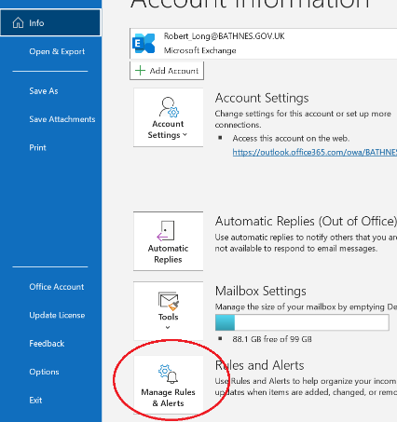

1. Select *New Rule*

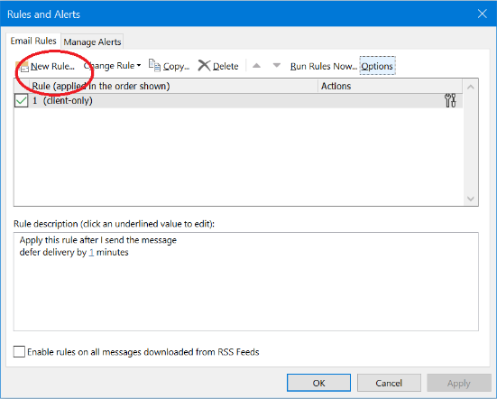

1. Select *Apply rules on messages I send*

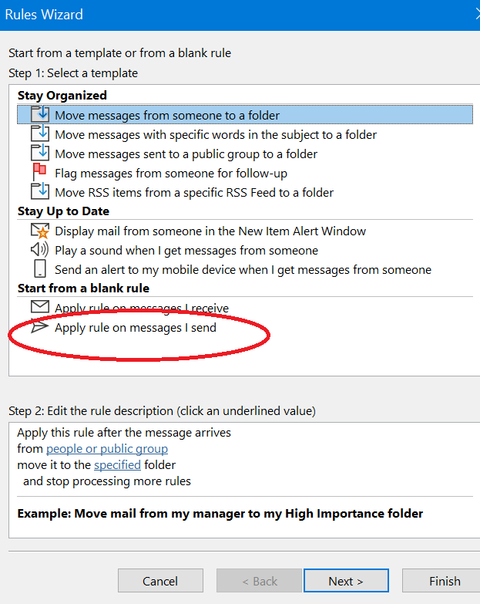

1. Click Next again – this will then bring a prompt – Click Yes

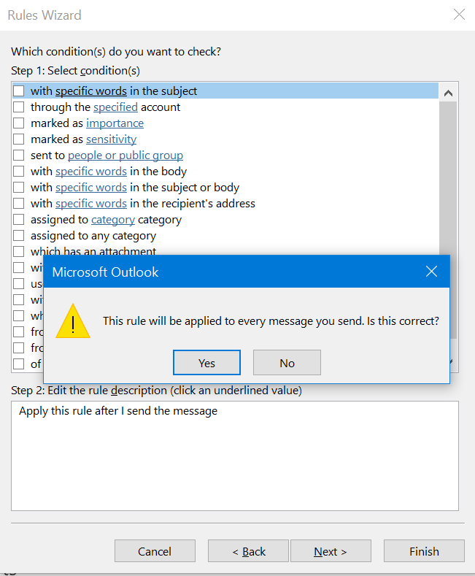

1. Click the *defer delivery by a number of minutes* box

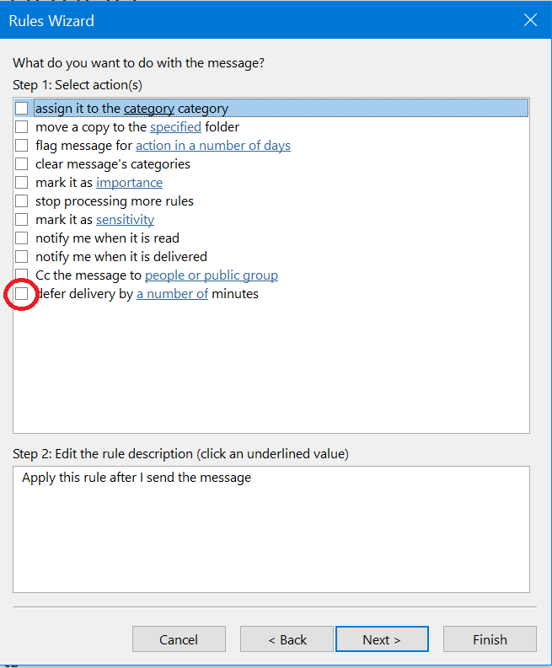

1. Then click the link in *number of* minutes and set your time delay

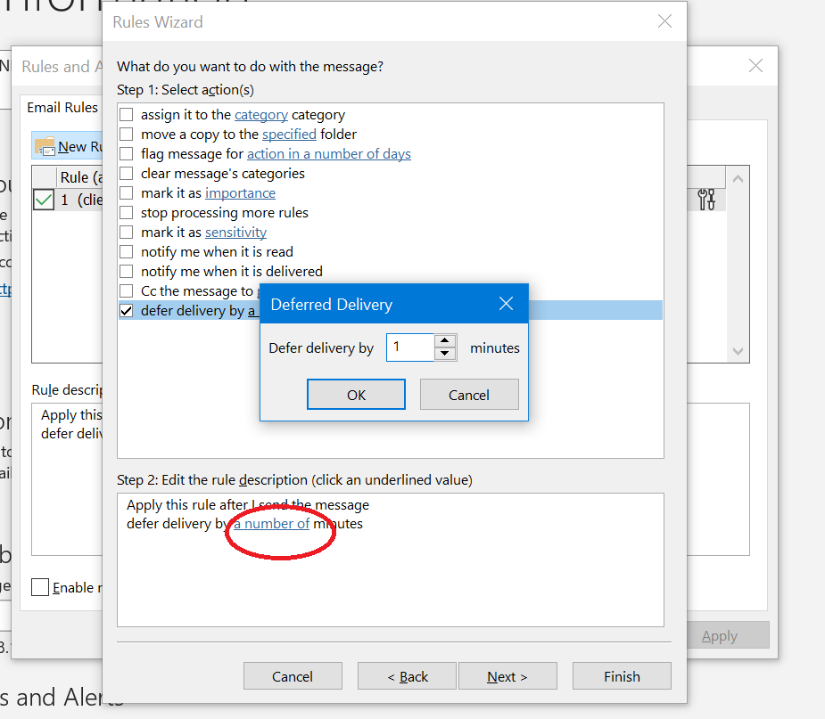

1. Click Next, Next & Finish