Visitor and pupil late / absence logs contain lots of personal information but are frequently left within the access and sight of others which amounts to a data breach. This guidance helps you to manage this information securely.

Visitor Books
The first thing to ask yourself is what is the purpose of your visitor book? In the majority of cases, it is for fire safety and knowing who is in the building at a particular time, or sometimes as a record of who is on site for safeguarding purposes. What is important is identifying what your school’s purpose of the visitor book is, as this will then shape the information you need to capture, and how long you need to retain it. You must then inform everyone of this, by way of a Privacy Notice.
The important point to remember is just because the design of the system / book means you can capture certain information, doesn’t mean that you should. Only capture what you need!
Our experience is that these logs tend to capture excessive information for the purpose, and most do not include any privacy information telling visitors why their information is being processed, under what legal basis/condition, and how long it is held for. This also applies to any electronic visitor management systems (VMS sometimes reveal information on all visitors onsite when signing out).
The main risk with visitor books is that you reveal information to others who do not have the need to know. For example, you may deem it in the school’s legitimate interests to record a number plate in case someone is blocked in, but you should not provide the details of one car owner to another as this would constitute a personal data breach. There are some visitor logs which mitigate this risk by having perforated badges, and a carbon copy underneath so that information is not revealed – however whilst compliant, these books tend to be costly.
A typical visitor log, and what can be revealed:
I’ve always wondered who owned that flash car with the personalised plate!
He’s my neighbour I didn’t realise he works for the Police!

Date | Name | Company | Visiting | Car Reg | Time In | Time Out
4/7/18 | Jon Doe | Police | Johnny Briggs | FN18 JHG | 12:00 | 13:00
4/7/18 | Jack Sparrow | ASL Ltd | School | JKS P8RW | 13:10 | 15:10
5/7/17 | Alice Keys | Social Care | Jack Smith | CV16 KMN | 9:05 | 11:45
5/7/18 | Liz Lewis | ASL Ltd | Head | BV17 DFC | 9:10 | 10:20
Liz Lewis: Hmmm Jack Sparrow told me he was here until 5pm yesterday!
Is that who she works for, perhaps I’ll find her later on social media
I didn’t realise little Jack has social care involvement. I wonder what that is all about?
So, what can we do?
Think about how much information you need to fulfil the purpose: you must only collect what you need. So, it could be simply:
Date | Name | In  (tick) | Out  (tick)
4/7/18 | R Smith |  |  | * If a fire drill occurs, I know Liz is the only visitor in the building
4/7/18 | Liz Banks
4/7/18 | James Bend

Sometimes car registration numbers are requested even when people don’t park on site: this should not be the case. You may even capture their car registration if you regularly have cars blocked in, but rather than capturing it as a default, why not simply ask the visitor if they are blocking anyone in?
In larger schools it may be that you do need to know who they are visiting so you can locate them in an emergency. If this is case, then ensure it is clear that it is the locality or school staff member that they enter in the log. | Staff member or location visiting
 | Head of Yr 8
 | Art Dept

You could use a page of blank labels/stickers with name, date, time, visiting whom etc which each visitor completes, and when completed they pass to office staff who stick them into a book/log behind the hatch which can be grabbed quickly in the event of an emergency.

How long should I keep the records for?
There is no “official” retention period for Visitor logs. PURPOSE defines how long you need to keep them.
For example, if the sole purpose of your visitor book is to identify who is in the building in the event of a fire, the only information you need to capture would be where they’re likely to be, and the log can be destroyed at the end of each day. Alternatively, if you’re using your visitor book to record whether someone has been in the building in the last three months for DBS purposes, you would need to know who they have come to see, and the retention would be three months.

Privacy Information
As we’re capturing personal data within the log, we must provide privacy information to explain why. This does not need to be a long Privacy Notice, but it could be something like:
As a visitor, we capture your personal data for the purpose of [locating you in an emergency / safeguarding yourself and others / …]. Car registrations are captured for your and our legitimate interests, in case there is a problem with your vehicle. We retain visitor data for [X period of time]. If you wish to discuss how we process your personal information, please speak to the School Office or our Data Protection Officer.
If you are using an electronic Visitor Management System, this privacy information needs to be on the first page of the screen, and it is up to YOU to notify the provider how long you want the records to be retained for (not the other way round, as is sometimes the case).
Pupil Late / Absence Logs
As with visitor books, these logs can easily reveal information to others who do not have the need to know. However, there is also a risk that with these logs sensitive information (eg health data) is also revealed in the reason, and as it is a free text box some will write broad information like “medical” or “hospital” and others will write lots of detail.
A typical log, and what it can reveal:
Matt: Jimmy’s Mum slept in! I’m going to make a comment to him about that!

Sean: I didn’t realise John in my class had mental issues; I’m going to wind him up about that!
Date | Name | Class | Late or Leaving | Reason | Time
4/7/18 | Jimmy Ryan | 8SJ | Late | Mum slept in | 8:55
4/7/18 | John Jacobs | 9HN | Leaving | CAMHS appointment | 11:10
5/7/18 | Michelle Doe | 8SJ | Leaving | Operation on ear | 10:10
5/7/18 | Sean Jones | 9HN | Late | Car broke down | 9:08
5/7/18 | Matt Smith | 8SJ | Leaving | Dentist | 14:10
Matt: And Michelle in my class has hearing problems – she kept that quiet!

So, what can we do?
Do you need to capture the reason on the log? - In the majority of cases you may already know about the reason for leaving and have this on your MIS (eg SIMS)?
Can you capture the information in a different way? Could we get office staff to complete it (behind the desk) rather than getting the pupil/parent to complete it?
You could have a slip for each entry which is completed by each student/parent and passed to Reception / Student Services?
You could use some card to cover up previous entries?
[Be careful of capturing the reason verbally and the risk of others in the vicinity overhearing]
You could use a page of blank labels/stickers with name, date, time, reason etc which each pupil/parent completes, and when completed they pass to office staff who stick them into a book/log behind the hatch which can be grabbed quickly in the event of an emergency?

Sign-In Sticker Templates
We have created some sticker templates below (for a page of 3x7 stickers), for you to use, and edit if you need to. We have created a template for: visitor sign in and out, pupil late sign in, and pupil early sign out.
To edit the template:
- Start by clicking on the template you need to change.
- Click on the Mailings tab.
- Click on the Labels icon on the far left, a window will pop up. At this stage you can change the text which appears.
- Click on Options, and another pop up will appear.
- Click on Details
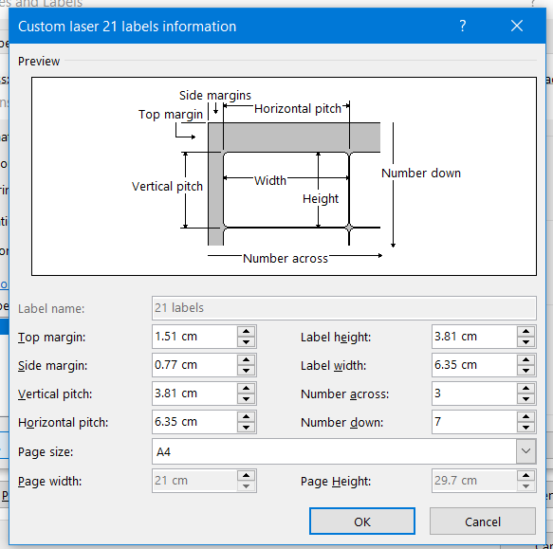
- A final pop up will appear, which looks like this:
- You can now edit all the measurements of the label to match whatever you are using.
Name:  Date:  Visiting:  Time In:  Car Reg:  Time Out: | Name:  Date:  Visiting:  Time In:  Car Reg:  Time Out: | Name:  Date:  Visiting:  Time In:  Car Reg:  Time Out:
Name:  Date:  Visiting:  Time In:  Car Reg:  Time Out: | Name:  Date:  Visiting:  Time In:  Car Reg:  Time Out: | Name:  Date:  Visiting:  Time In:  Car Reg:  Time Out:
Name:  Date:  Visiting:  Time In:  Car Reg:  Time Out: | Name:  Date:  Visiting:  Time In:  Car Reg:  Time Out: | Name:  Date:  Visiting:  Time In:  Car Reg:  Time Out:
Name:  Date:  Visiting:  Time In:  Car Reg:  Time Out: | Name:  Date:  Visiting:  Time In:  Car Reg:  Time Out: | Name:  Date:  Visiting:  Time In:  Car Reg:  Time Out:
Name:  Date:  Visiting:  Time In:  Car Reg:  Time Out: | Name:  Date:  Visiting:  Time In:  Car Reg:  Time Out: | Name:  Date:  Visiting:  Time In:  Car Reg:  Time Out:
Name:  Date:  Visiting:  Time In:  Car Reg:  Time Out: | Name:  Date:  Visiting:  Time In:  Car Reg:  Time Out: | Name:  Date:  Visiting:  Time In:  Car Reg:  Time Out:
Name:  Date:  Visiting:  Time In:  Car Reg:  Time Out: | Name:  Date:  Visiting:  Time In:  Car Reg:  Time Out: | Name:  Date:  Visiting:  Time In:  Car Reg:  Time Out:
Pupil Name:  Date:  Time in:  Reason: | Pupil Name:  Date:  Time in:  Reason: | Pupil Name:  Date:  Time in:  Reason:
Pupil Name:  Date:  Time in:  Reason: | Pupil Name:  Date:  Time in:  Reason: | Pupil Name:  Date:  Time in:  Reason:
Pupil Name:  Date:  Time in:  Reason: | Pupil Name:  Date:  Time in:  Reason: | Pupil Name:  Date:  Time in:  Reason:
Pupil Name:  Date:  Time in:  Reason: | Pupil Name:  Date:  Time in:  Reason: | Pupil Name:  Date:  Time in:  Reason:
Pupil Name:  Date:  Time in:  Reason: | Pupil Name:  Date:  Time in:  Reason: | Pupil Name:  Date:  Time in:  Reason:
Pupil Name:  Date:  Time in:  Reason: | Pupil Name:  Date:  Time in:  Reason: | Pupil Name:  Date:  Time in:  Reason:
Pupil Name:  Date:  Time in:  Reason: | Pupil Name:  Date:  Time in:  Reason: | Pupil Name:  Date:  Time in:  Reason:

